Credit

2110

Assignment

E8 GuessingGame

Errors

What caused the error and how do you overcome the error?

Made an infinite loop

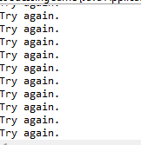

Second while loop caused it, removed it configured first while loop fixed it

